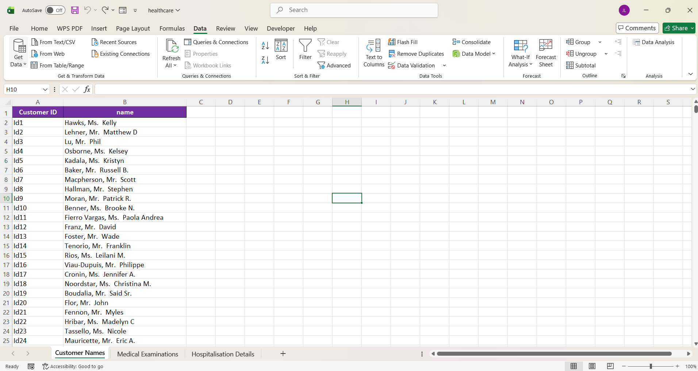
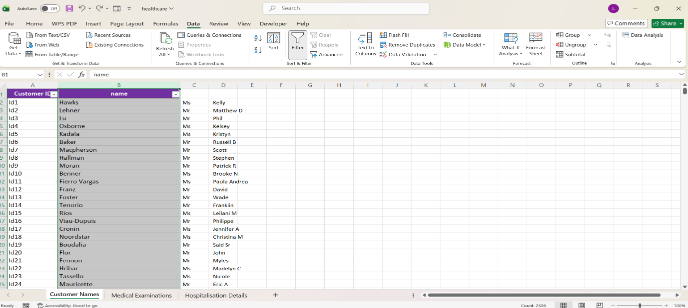
- Checked for duplicate values in customer name sheet. No duplicate values were found in the dataset.

- Split the Name column into three separate columns.

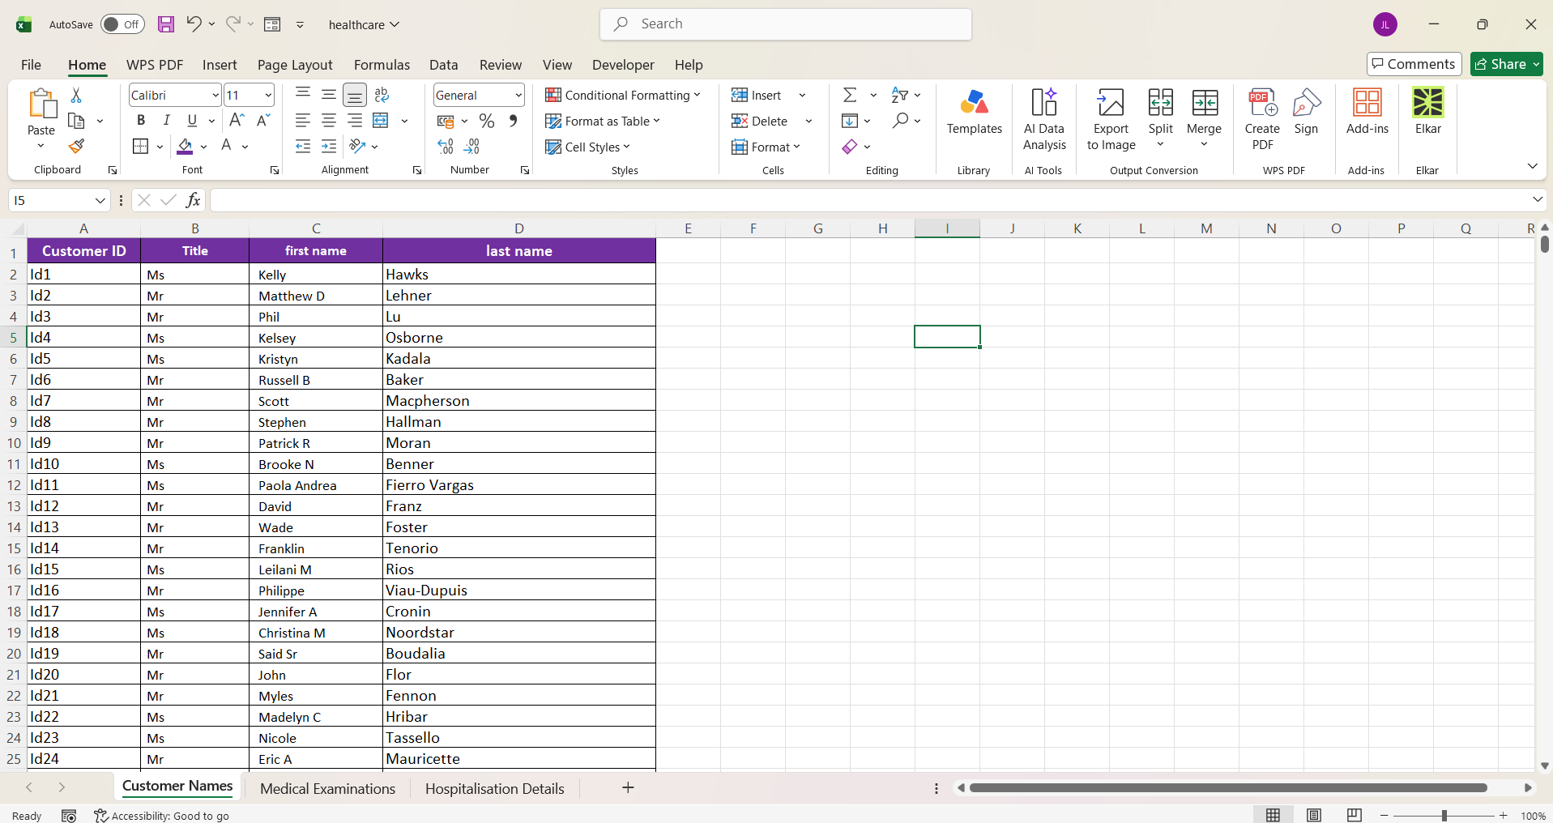

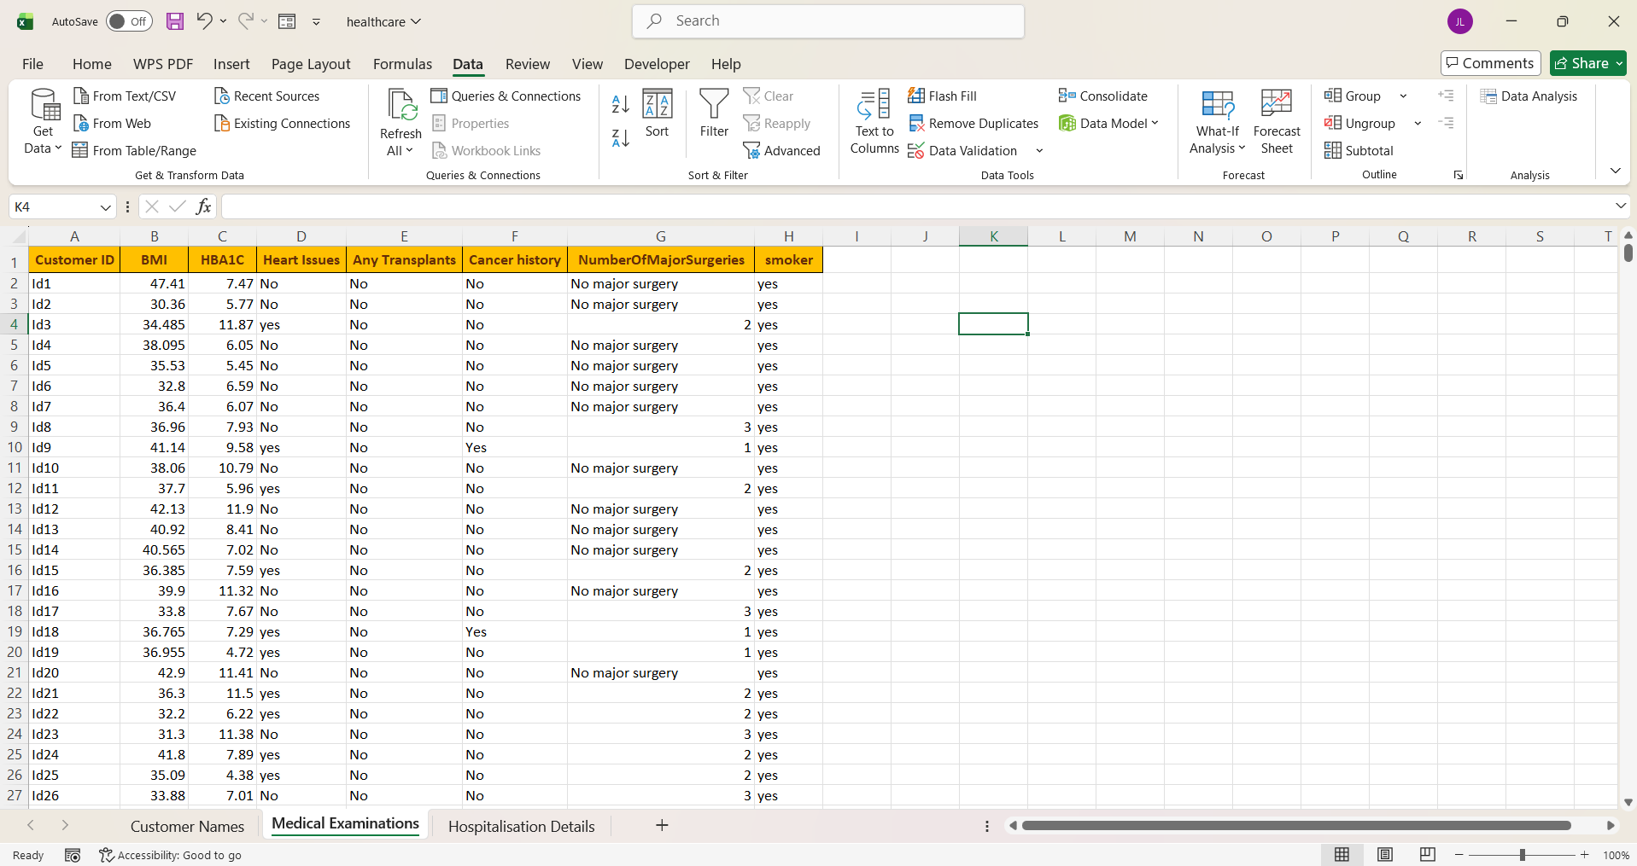
- Added appropriate headings for the three columns: Title, First Name, and Last Name. Then, added borders to the columns.

- Checked the Medical Examination sheet for duplicate values. No duplicate values were found.

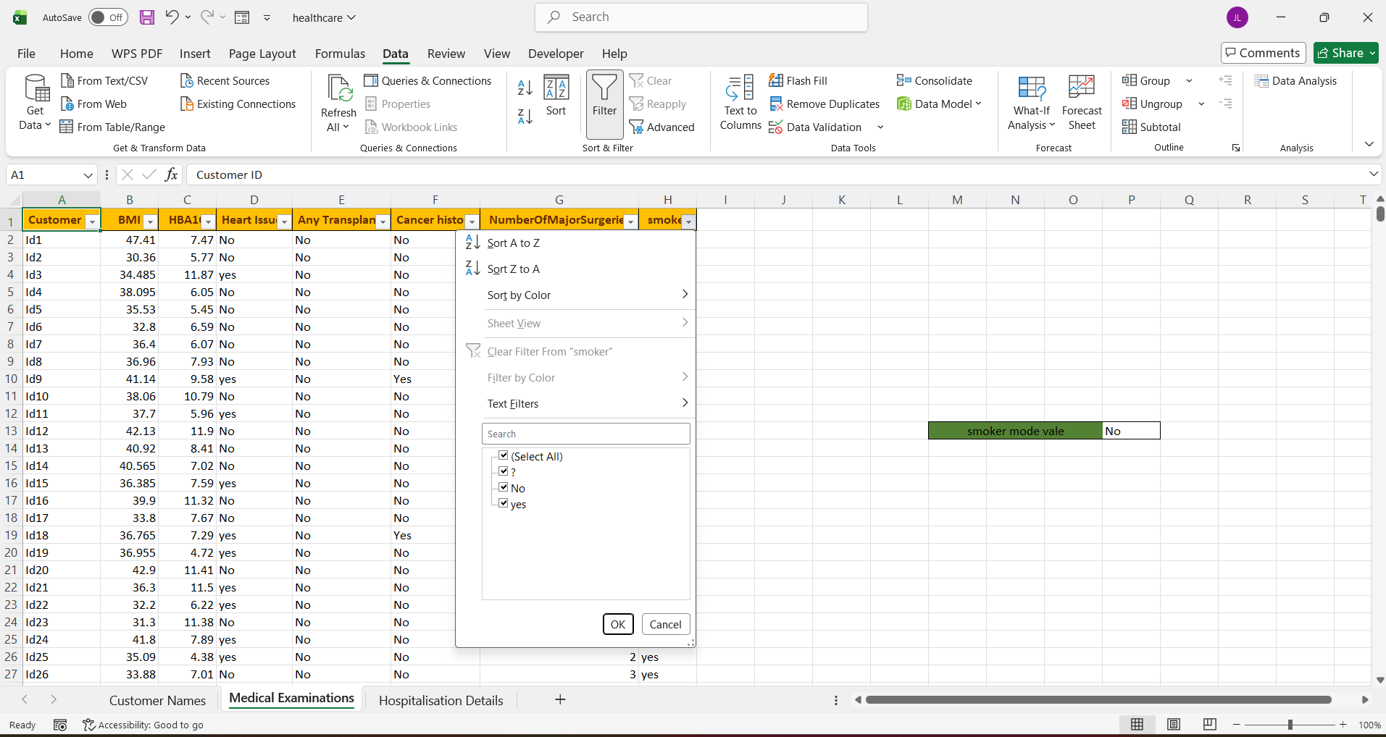

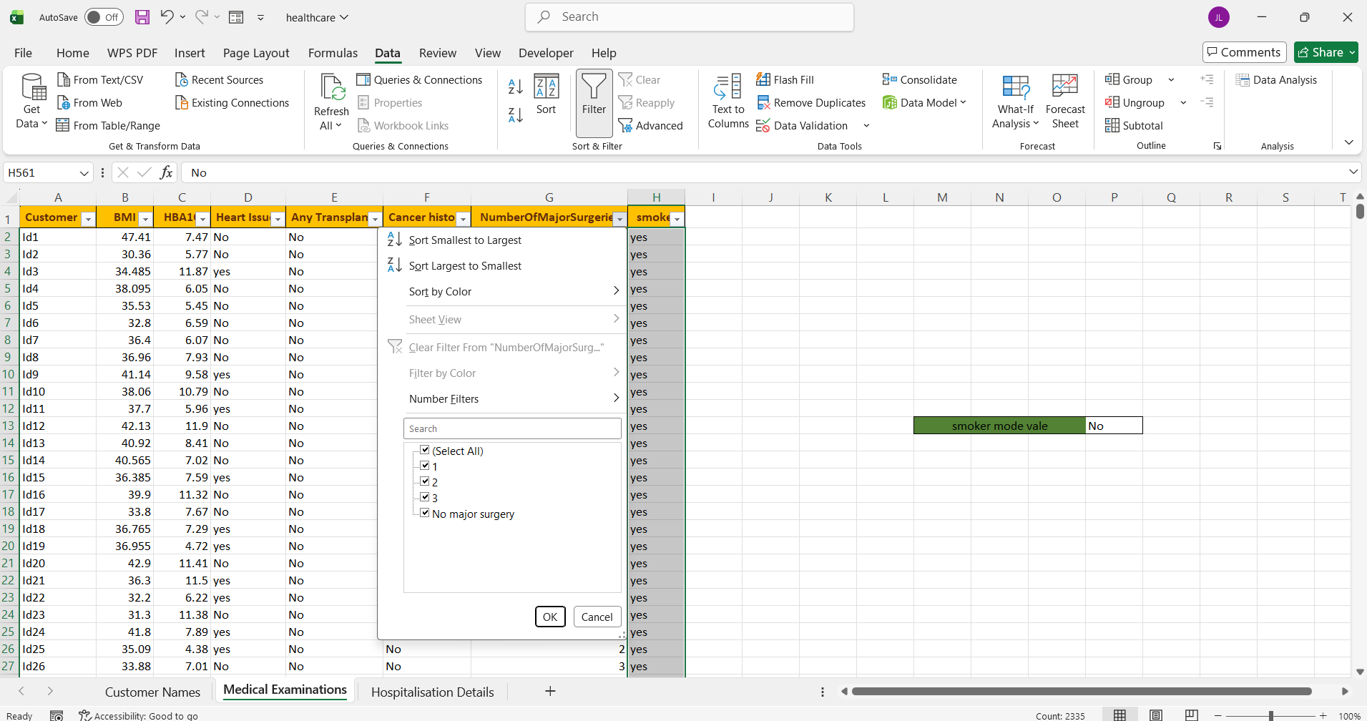
- Filtered all columns and checked the values. In the Smoking column, I found some question marks (?) along with Yes and No values. I identified the mode as “No” and used Find and Replace to replace the question marks with “No”.

- In the “Number of Major Surgeries” column, the values were in both numerical and text formats. I converted the “No Major Surgery” text value to 0 and kept all other values in numerical format.

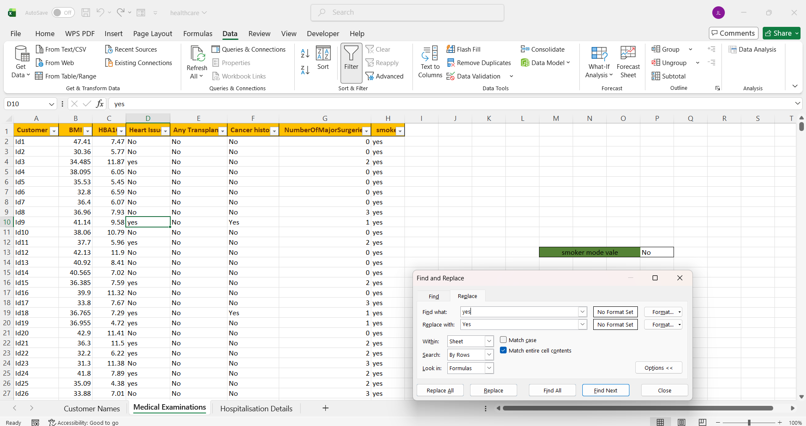

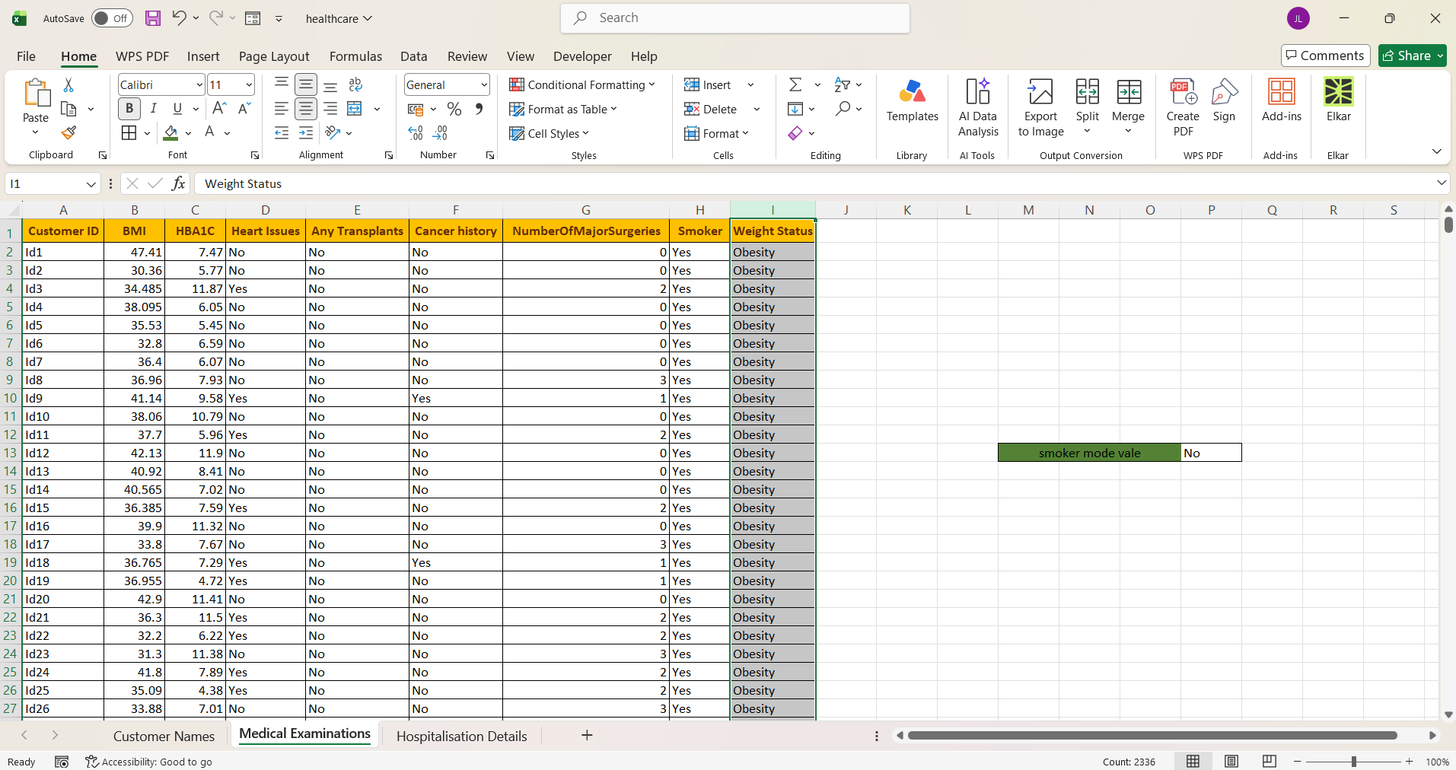
- Checked the Heart Issue and Smoking columns and corrected the inconsistent data.

- Created a new column called “Weight Status” based on BMI. Used IF conditions to classify the values as Underweight, Normal Weight, Overweight, or Obesity based on the BMI ranges.

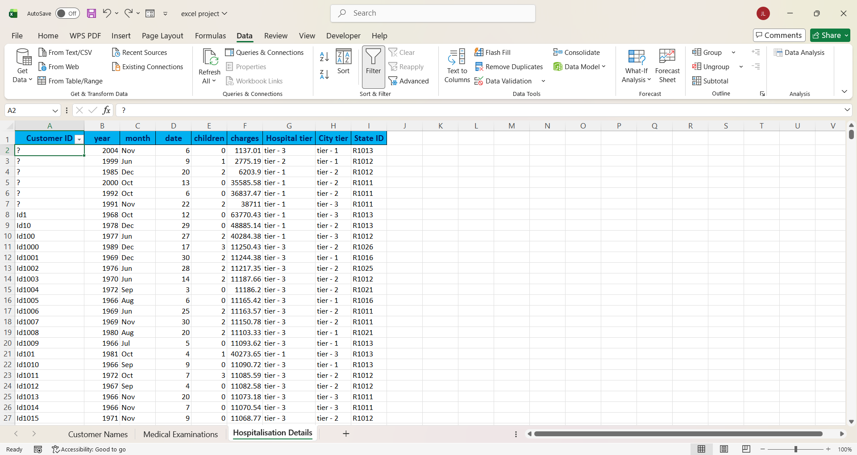

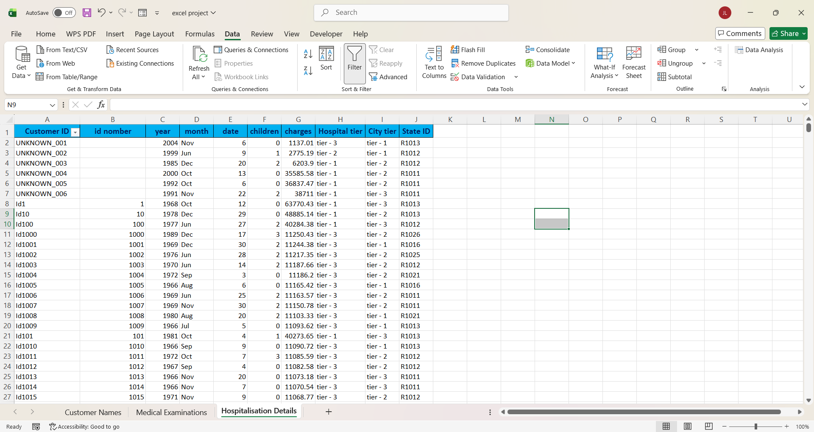
- Next, I moved to the Hospitalization Details sheet and checked for duplicates using the filter option. I found some question mark (?) values in the ID column. First, I tried sorting the IDs from smallest to largest, but the sorting was not correct because the IDs were treated as text. For example, the order was coming as 1, 10, 11 instead of the proper numerical order. Since I could not delete the original data, I checked the question mark values to find the appropriate way to handle them.

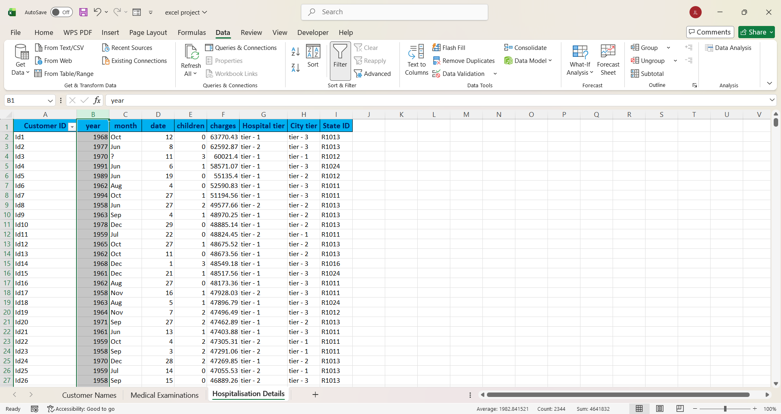
- Since I could not ignore the records with question marks, I replaced them with “UNKNOWN” and assigned different numbers to each record, such as UNKNOWN_001, UNKNOWN_002, etc., so that each ID remained unique. Next, to sort the IDs correctly in ascending order, I converted the text IDs into numerical values using the following formula: =IFERROR(VALUE(SUBSTITUTE(A2,"Id","")),"").

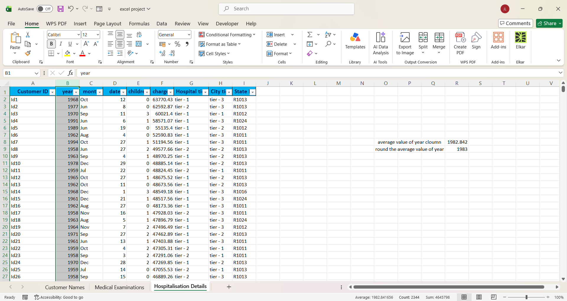
- Next, I sorted the table using the newly created ID number column and arranged the IDs in ascending order. After that, since the additional column was no longer needed, I deleted it.

- Next, I imputed the missing Month values as September and filled the missing Year values using the average of the available years. I then rounded the average to the nearest whole number and used it to fill the missing years.
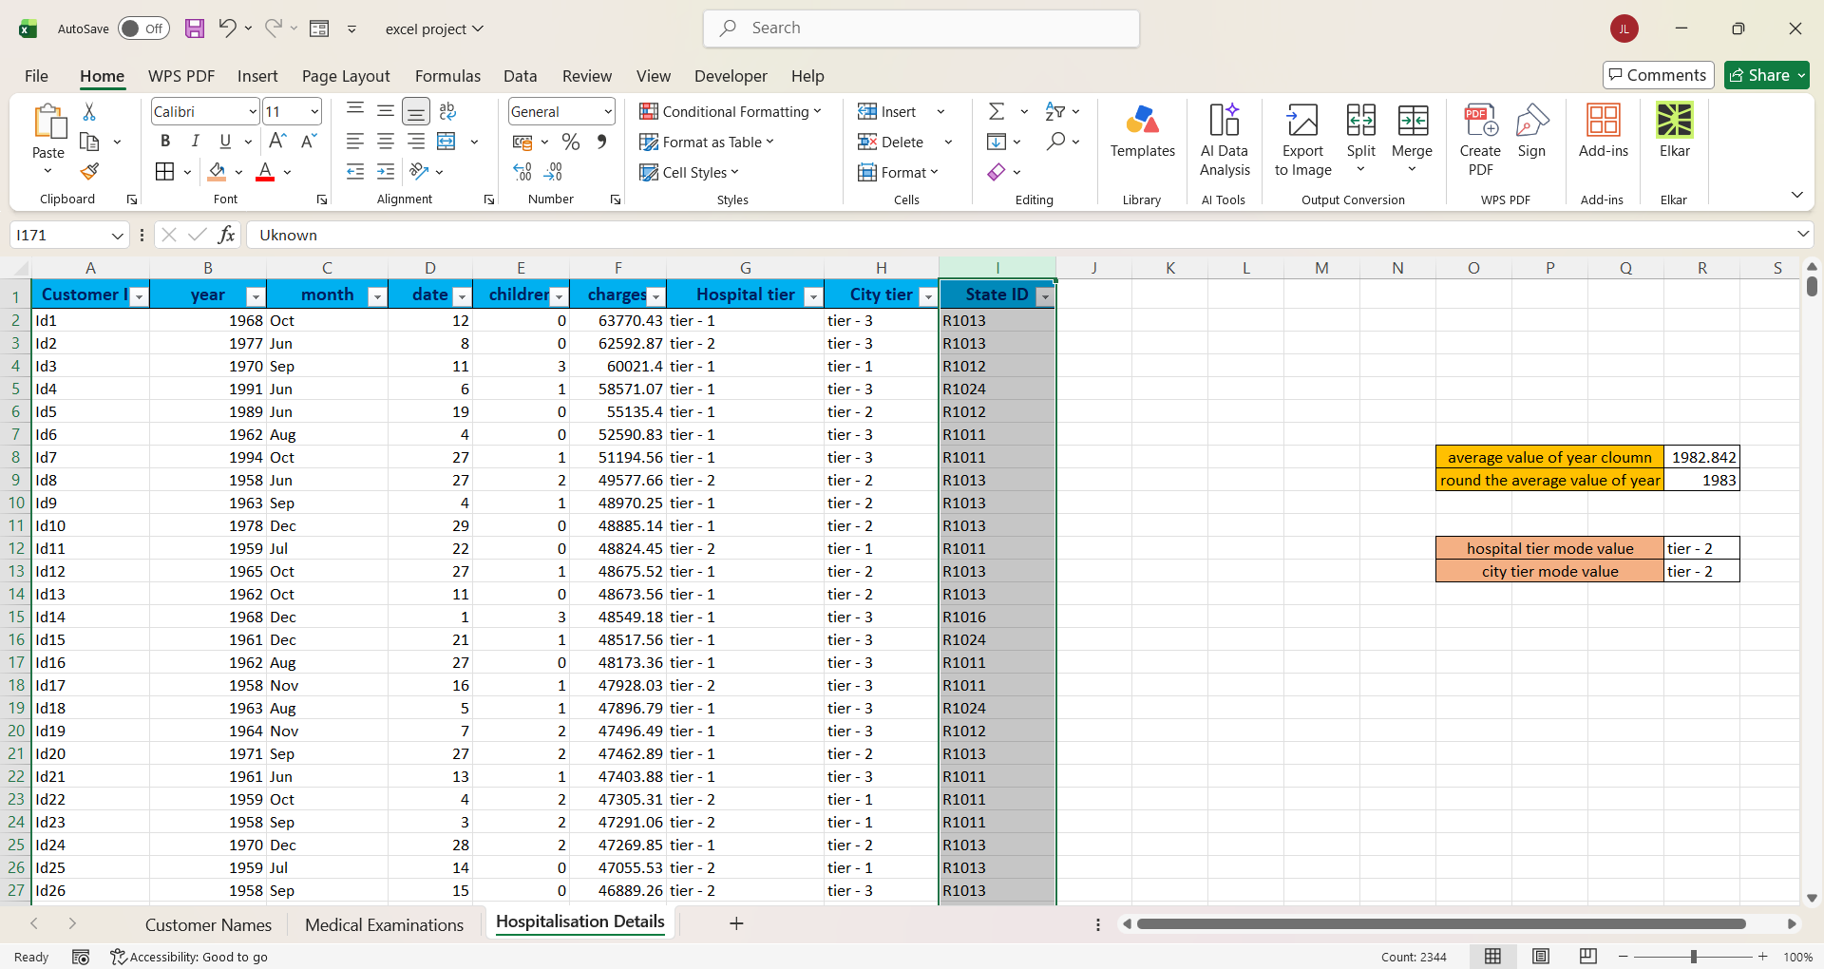

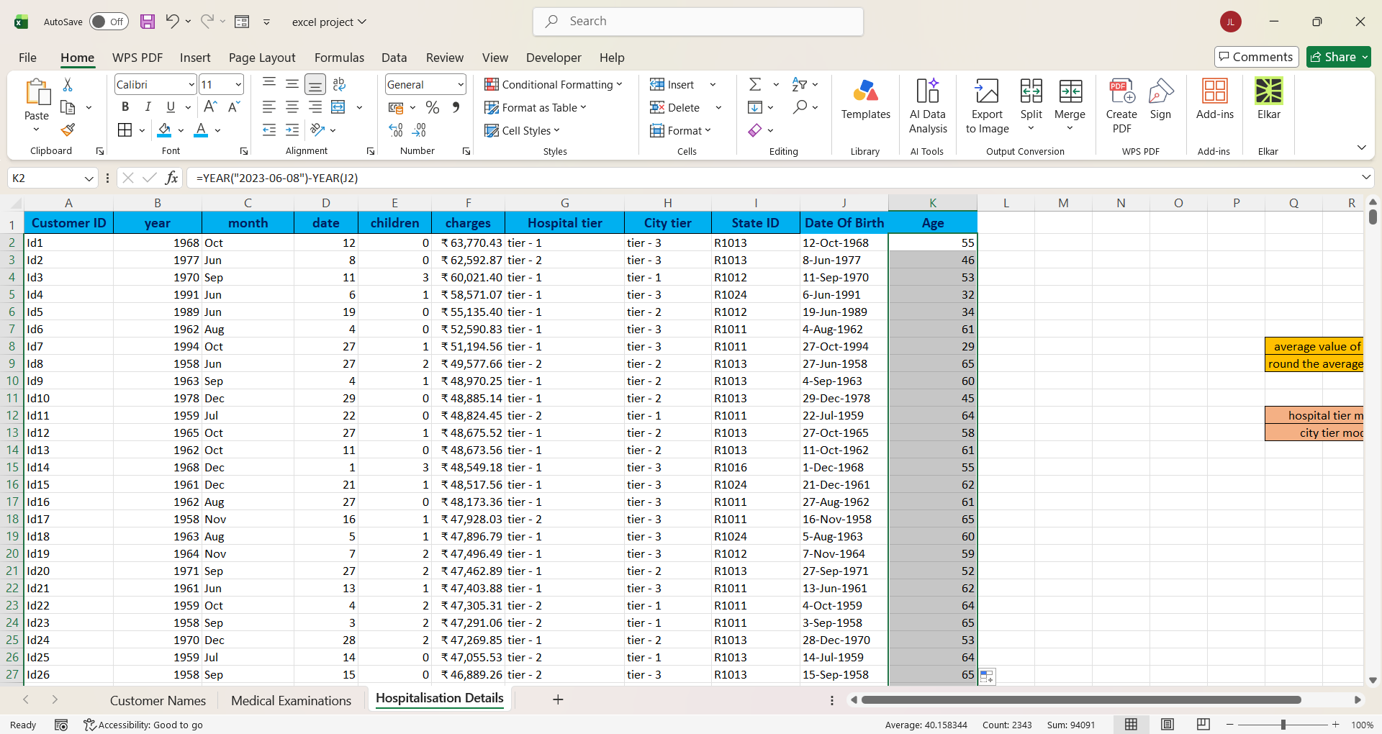
- Next, I filled the missing values in the Hospital Tier and City Tier columns using the most frequently occurring values (mode). Then, I filled the missing values in the State ID column with “Unknown”.

- Next, I merged the Year, Month, and Date columns into a single Date of Birth column. Then, I calculated the age of each customer based on the Date of Birth as of 8th June 2023. Finally, I changed the currency format in the Charge column.
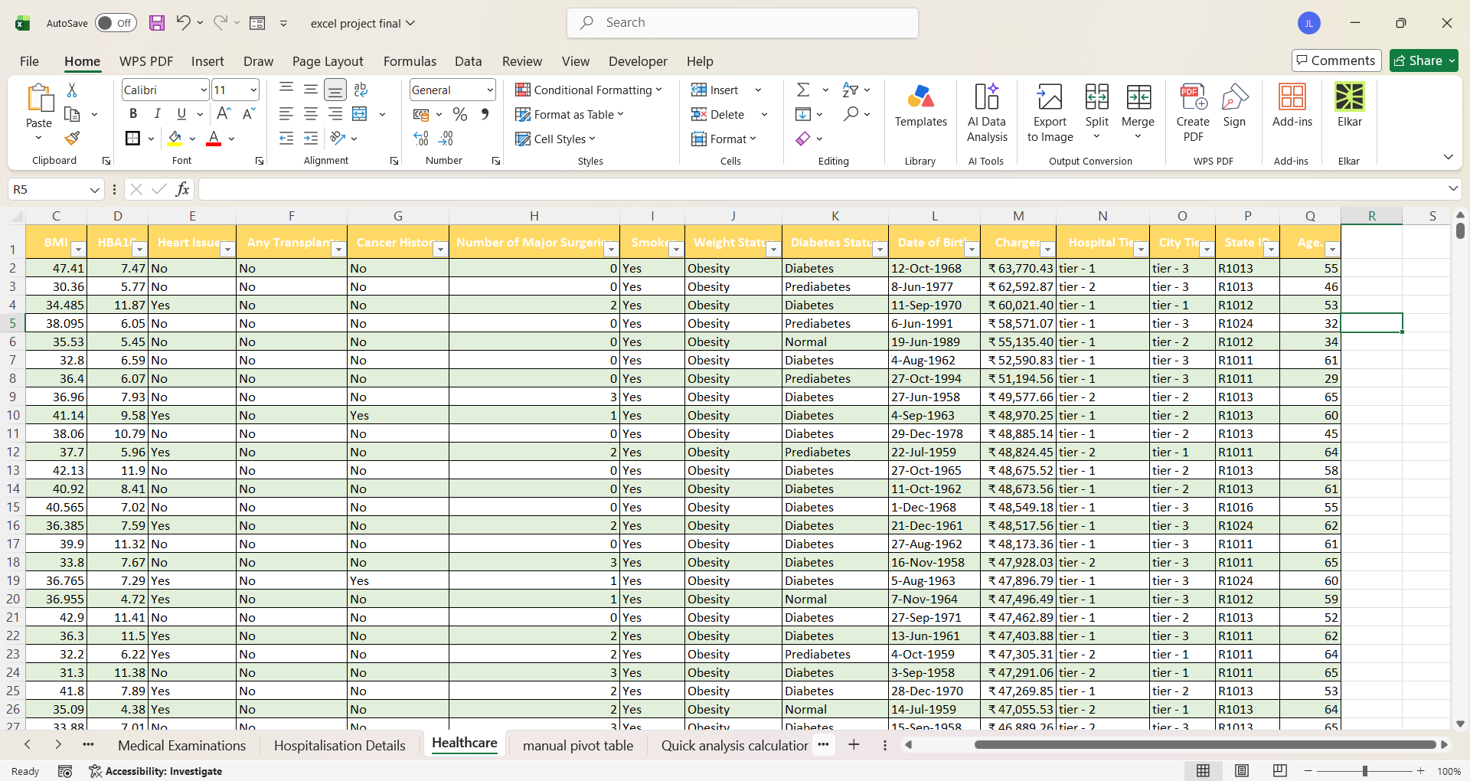

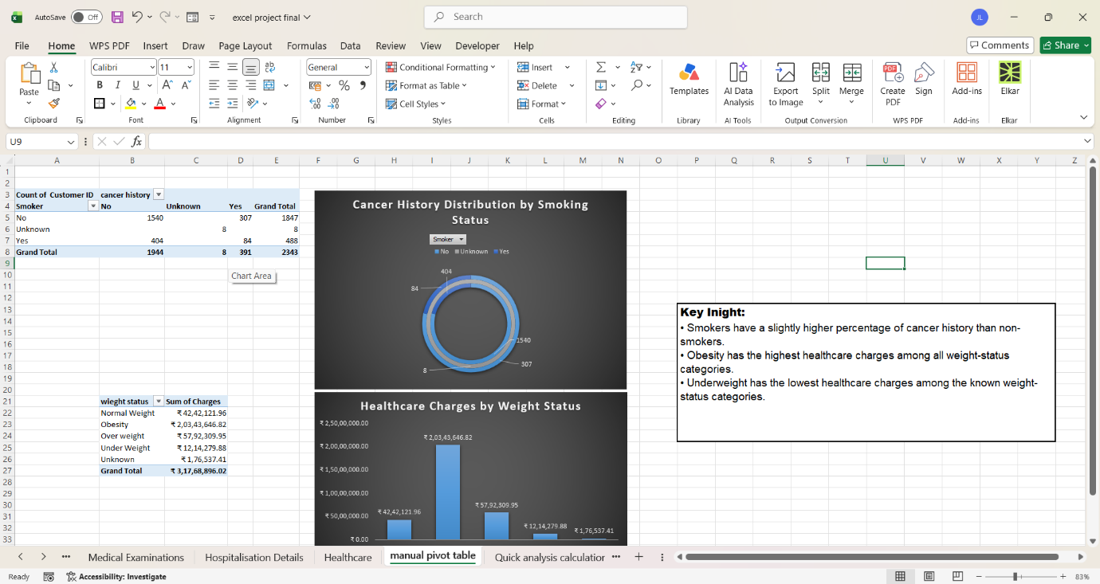
- Next, I created a new sheet and added all the required columns mentioned in the instructions. I used XLOOKUP to retrieve and add the required information from the cleaned data.

- Next, I created a new sheet called Manual Pivot Table. As per the instructions, I created a PivotTable for Cancer history distribution among smokers versus non-smokers and added a Donut chart. Then, I created another PivotTable for Charges by Weight Status and added a Column chart. I manually inserted and arranged all the required elements for both charts in the same sheet.

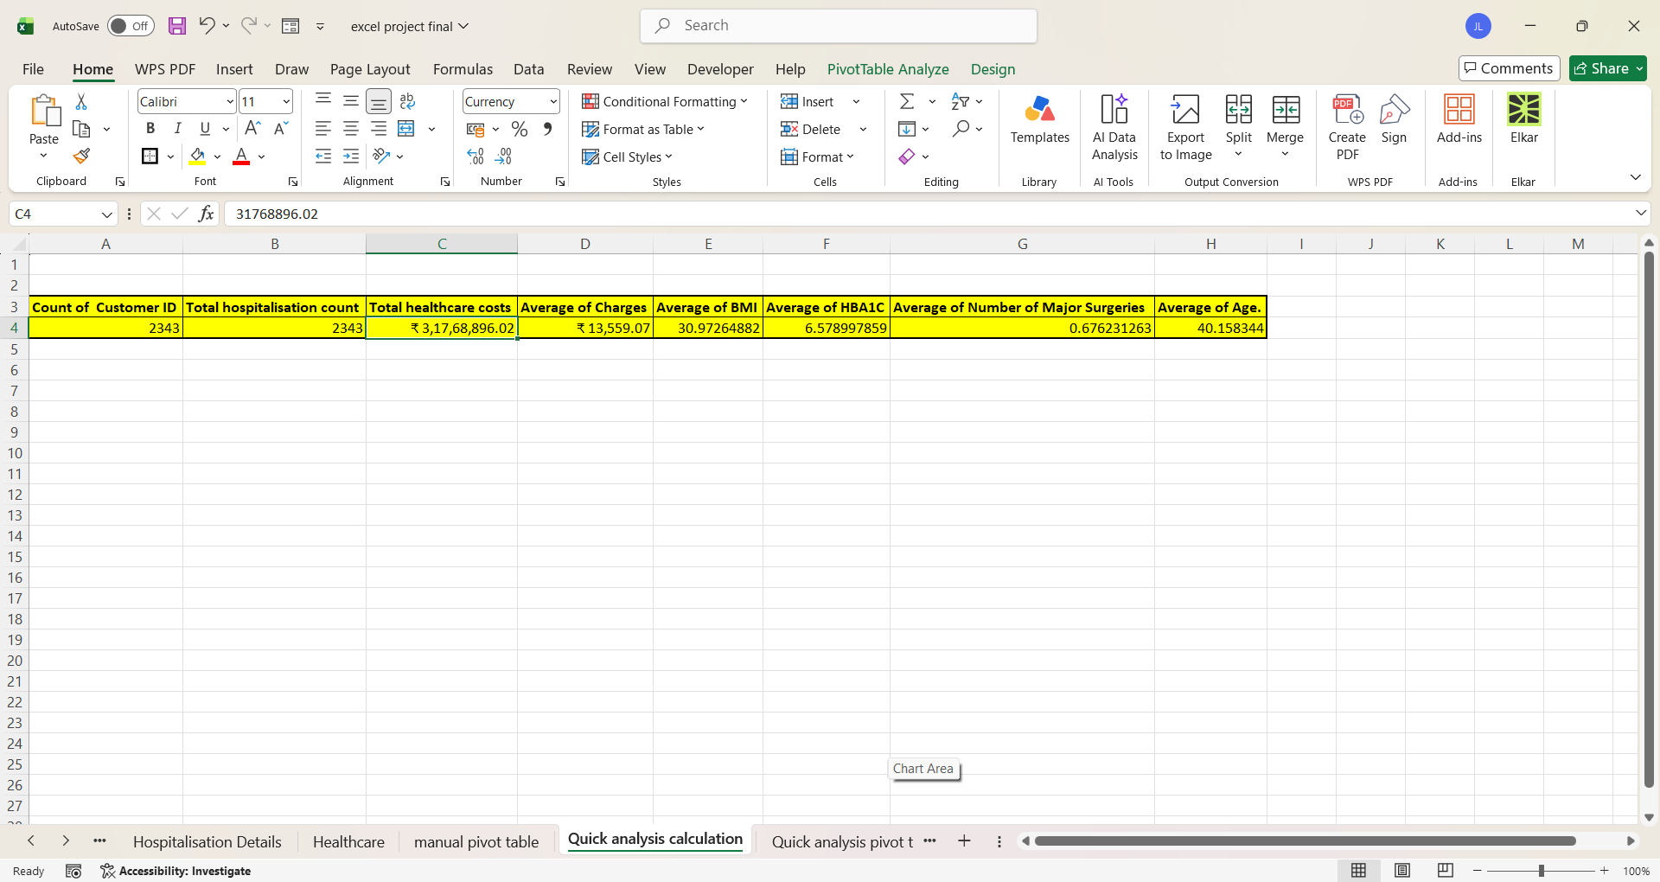

- Next, I created a new sheet called Quick Analysis Calculation. Using Quick Analysis, I performed the calculations mentioned in the instructions, including Total Customer Count, Total Hospitalization Count, Total Healthcare Cost, Average Healthcare Cost, and Medical Metrics.

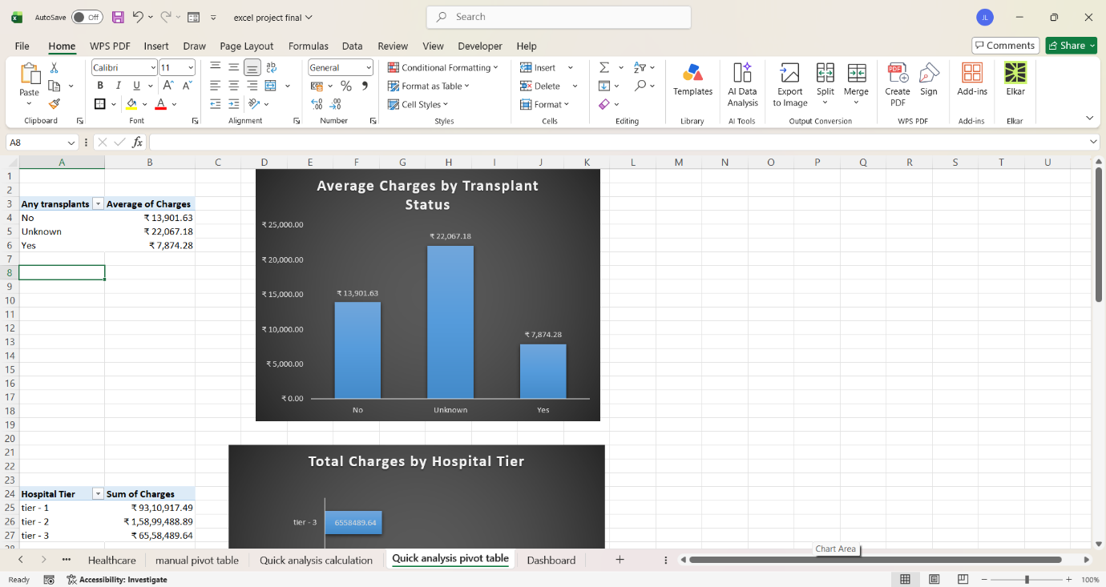

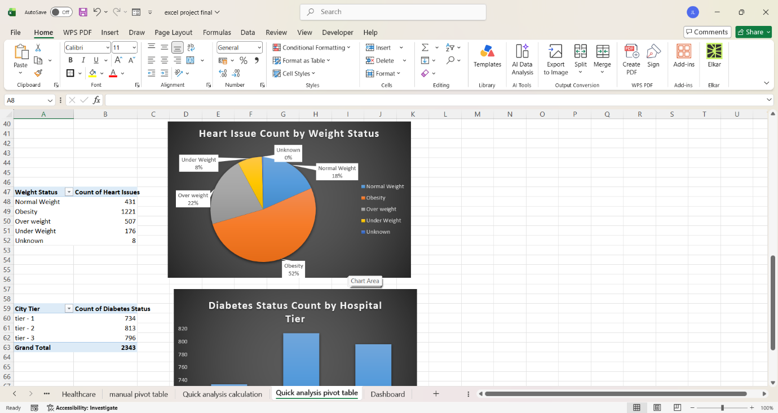
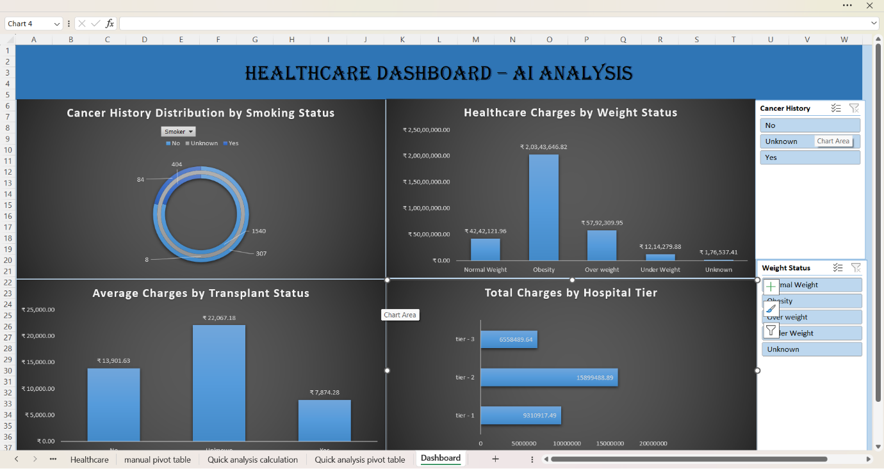
- Next, I created Quick Analysis Pivot Tables for the required analysis. I created PivotTables for Average Charges by Transplant Status, Total Charges by Hospital Tier, Heart issue Count by Weight Status, and Diabetes Status Count by Hospital Tier. I then created charts for these PivotTables using AI-assisted chart recommendations

- Finally, I created a new sheet named Dashboard and built my Healthcare Dashboard with AI Analysis. I added all the required charts to the dashboard. I also added slicers for Weight Status and Diabetes Status. From my point of view, the Cancer history distribution by Smoking Status needed a little more clarification, so I also added a Cancer history slicer to make the analysis more interactive and easier to understand. At the end of the process, I created my first interactive dashboard.

